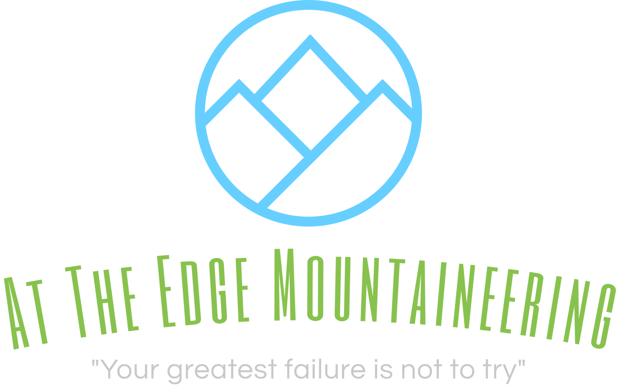
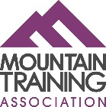

www.attheedgemountaineering.co.uk
info@attheedgemountaineering.co.uk
Book onto a course to receive the following benefits:
- 10% Discount off ‘Harvey Maps products’ www.harveymaps.co.uk/
- 15% Discount off ‘Water-to-Go products’ www.watertogo.eu/refer/681/
 |  |  | (Price per course)
Course | Ratio / Duration (Days) from |  | Open Individual | Bespoke/Private Group
Navigation

Intro to Navigation | 1:8 | 1 | £50 | £150/+£30pp extra
Intermediate Navigation | 1:8 | 1 | £60 | £150/+£30pp extra
Advanced Navigation | 1:6 | 1 | £70 | £150/+£30pp extra
Night Navigation | 1:6 | 0.5 | £30 | £50/+£5pp extra
NNAS Bronze | 1:8 | 2 | £125 | £300 (min 2 people) +£100pp extra
NNAS Silver | 1:8 | 2 | £135 | £320 (min 2 people) +£110pp extra
Scrambling

Intro to Scrambling | 1:4 | 2 | £150 | £300/ +£60pp extra
Guided Scrambling | 1:4 | 1 | £70 | £150/ +£30pp extra
Summit Days

Brecon Beacons | 1:10 | 1+ | £40 | £150/ +£5pp extra
Snowdonia | 1:10 | 1+ | £50 | £150/ +£10pp extra
The Lake District | 1:10 | 1+ | £50 | £150/ +£10pp extra
Scotland | 1:8 | 2 | £180 | £300/ +£30pp extra
Mountain Skills
Complete Navigation | 1:6 | 3 | £130 | £300/ +£30 pp extra
Wild Camping | 1:8 | 2 | £180 | £300/ +£40pp extra
Security on Steep Ground | 1:4 | 1 | £100 | £150/ +£30pp extra
Nav & Scrambling | 1:4 / 1:6 | 5 | £300 | £500/ +£150pp extra
Mountain Skills | 1:6 | 5 | £300 | £500/ +£150pp extra
Rock Climbing
Introduction to Climbing | 1:4 | 1 | £80 | £150/ +£30pp extra
Introduction to Climbing | 1:4 | 2 | £150 | £300/ +£60pp extra
Independent Climbing | 1:4 | 2 | £180 | £300/ +£60pp extra
Climbing Skills  (Rigging/abseiling/belays) | 1:6 | 1 | £100 | £150/+£30pp extra
Guided Climbs | 1:2 | 1+ | N/A | £150 (1:1)  £200 (1:2)
Taster/group day | 1:12 | 0.5 | N/A | £40pp (min 4 people)

